Pg. 119 – 127, Java Programming *A comprehensive Introduction*

Pg. 211-212 , Java Programming *A comprehensive Introduction*

Class and Object expanded

**Define**

Procedural Programming-

Step by Step process for executing the code

Object Orientated Programming-

Objects subset or apart of some class

Class are involved

Methods / Actions

Does not operate in linear execution pattern.

Why do we build complex programs in pieces?

Easier to make changes

Make it easier to debug

Easier to work with other programmers/ collaborate

Reuse code that has already been created

Creating classes allows programmers to create programs in pieces.

Describe the purpose of **main()** –

Where program start.

We want main to organize execution of program.

We want “all actions” performed by the program to take place outside.

“programmer created” class-

Place where we can create instance variables.

Create custom methods to solve problems

Instance variables / class variables-

Variable of some type that exist inside a “Programmer created class”

Why are “programmer created classes” important in programming?

Types of objects- Access to primitive data type or the individual, that make up a data structure, class, or string.

How are object created?

Using keyword “new”

“programmer created” method-

*dot.operator- use to access the methods in a class*

Examples of dot.operator we have used in previous programs-

.lenght();

Math.random()

.nextInt();

Describe the purpose of the following statement

Vehicle minivan = **new** Vehicle(); - Create a class object

void method- use to set a value, or using for System.out.Println Options

Void method performs action we want to execute in the program.

Pg. 123, Java Programming *A comprehensive Introduction*

**Programming Assignment**

Task 1- Create a computer program that will calculate the range for 3 different vehicles.

The program should create a “programmer created” class, where 3 **int** **objects** are created passengers, fuel capacity, mpg.

Create a **void()** method inside the “programmer created “ class to calculate vehicle range**.**

**range =** **fuel capacity * miles per gallon**.

Each Vehicle type should have unique values for number of passengers, fuel capacity, and miles per gallon.

Follow the sample below and return information on 3 vehicle types.

**Sample Output: // Create similar output for 3 Vehicle Types**

The minivan carries= 7

The minivan has a fuel capacity of = 16

The minivan mpg = 21

The minivan has a range of: 336 miles

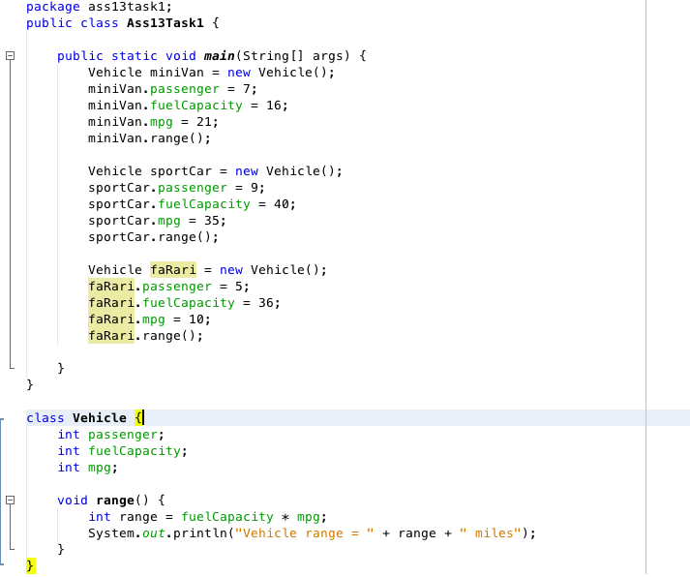

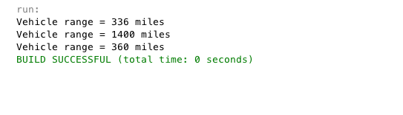

Pg. 151, Java Programming *A comprehensive Introduction*

*#13* Modified Version

Task 2- Create a **Die** “programmer created” class. Inside the “programmer created class” create 2 instance variables, each instance variable will be an integer type.

Create a void method that returns the value of a die roll. (random number between 1-6)

Create a void method that output the value of two dice being rolled.

All calculations and integer assignment will take place in the “programmer created” class. **main** in your program will only operate the execution of the program.

Output will be the value of one random die roll and then the value of 2 random dice being rolled.

**Sample Output**

1 die Roll = 5

2 dice Roll = 7

**Example of main in the program.//**main only contains calls to methods/objects created in the “programmer created” class

public class DieRollClassDemo {

public static void main(String[] args) {

Die rollingdice = new Die();

rollingdice.dieroll();

rollingdice.diceroll();

